**Ideation Phase**

**Brainstorm & Idea Prioritization**

|  |  |
| --- | --- |
| Date | 17 September 2022 |
| Team ID | PNT2022TMID27756 |
| Project Name | Project - AI-powered Nutrition Analyzer for Fitness Enthusiasts |
| Maximum Marks | 4 Marks |

**Brainstorm & Idea Prioritization:**

1. **AGE BASED :**

The project will focused on different age of people who is searching for a good nutrition food. For different aged people different foods will be suggested. This was a good advanced idea that was implemented in a project. Which will help the project to reach more people with ages. While following this instructions people can become more fit and healthy. Some foods suggested in the project may be not liked by small aged people (children) which can be say as a drawback of the project.

1. **DISEASE BASED :**

The project illustrates about human body diseases which varies from people to people based on their health conditions. The purpose of this disease based analysis is to define a patient's nutritional status, to define clinically relevant malnutrition and to monitor changes in nutritional status. Nutrition assessments are very important in human medicine as in most chronic malnutrition are common clinical findings during clinical examinations. This nutrition based will help people to take correct diet plan for various disease which varies from people to people. This project is one of the advanced idea in medical field that can be implemented in the future for the drastic medical world.

1. **GENETIC BASED:**

This project aims to develop a DNA-based diet which is derived from your genetic structure/DNA is the blueprint of your life. The genetic test report will have an evaluation of your genetic build and recommendations to counter the risk factors. Based on your genetic test report it shows you about the kind of exercises to enhance your fitness and also lays out all the health conditions that you might be predisposed to. This can help you to prevent the onset of those health conditions by following the recommendations of genetic counsellor and also personalizing your lifestyle including your health checkup routine. The major drawback of this project is that the genetic based diet fails to consider risks such as obesity and anorexia and is not based on a complete clinical picture of one’s dietary needs, existing health conditions, and medications

Reference:

https://app.mural.co/invitation/mural/ainutrition4264/1667208382080?sender=u71cea5f9692b1c447c051207&key=fc70af38-1772-4552-9bb1-4faae7f4e8b7

**Step-1: Team Gathering, Collaboration and Select the Problem Statement**

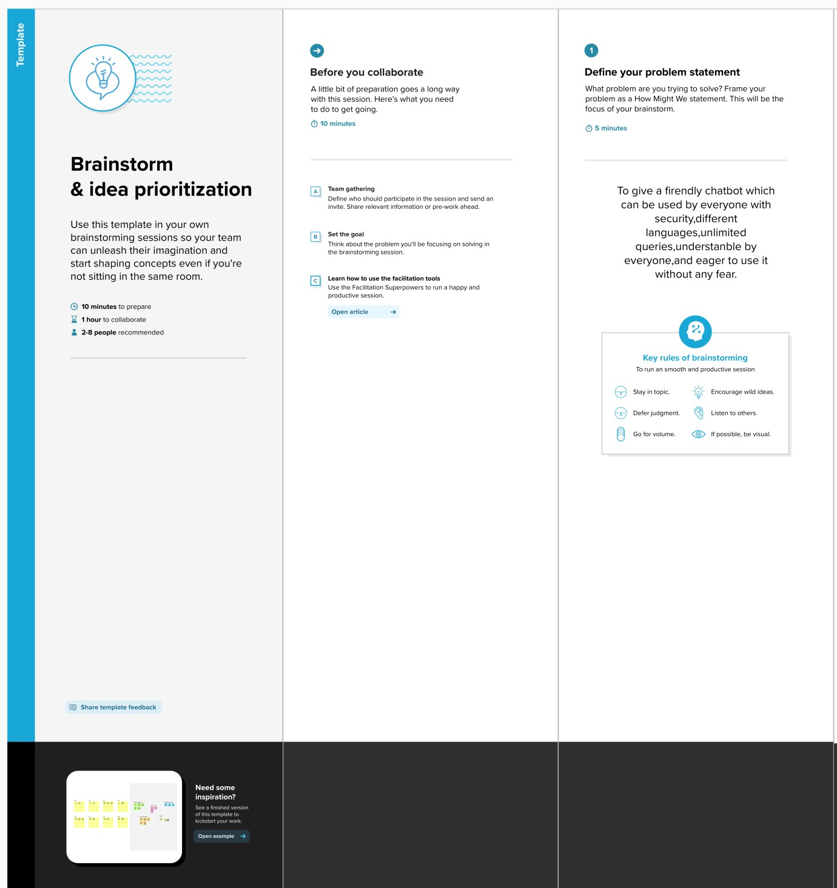

**Step-2: Brainstorm, Idea Listing and Grouping**

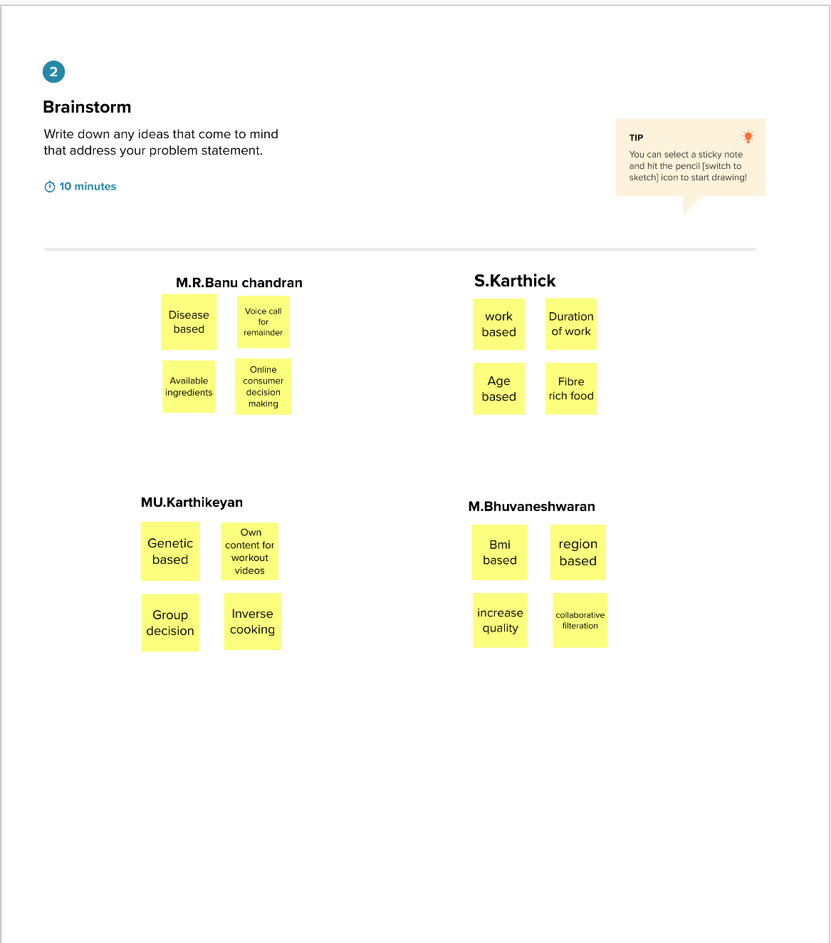

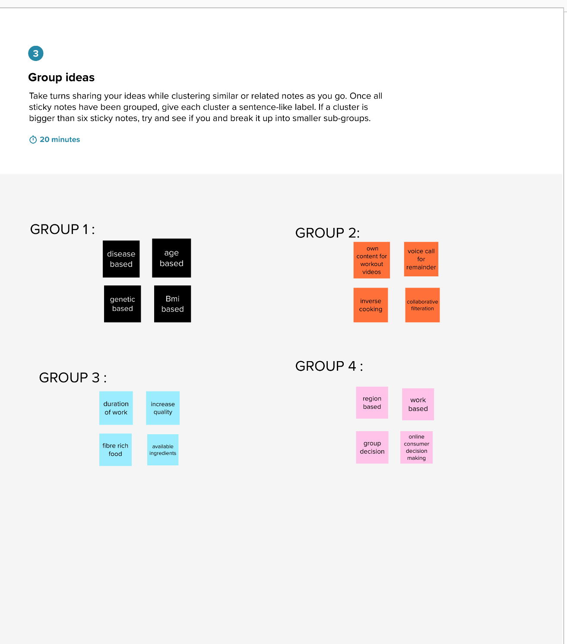

**Step-3: Idea Prioritization**

